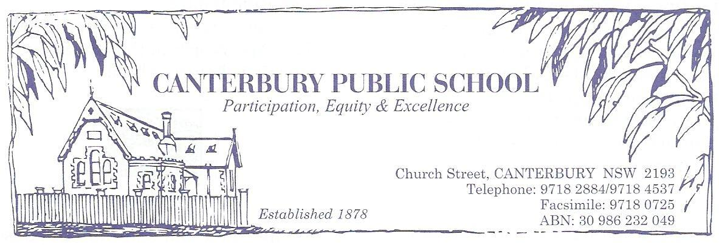
STUDENT BRING YOUR OWN DEVICE (BYOD) IMPLEMENTATION
GUIDELINES

1. Introduction

This document outlines in detail how BYOD will be implemented within Canterbury Public School.

1.1 The term “device” in this policy refers to any personal mobile electronic device with the capability to connect to the department’s Wi-Fi network, or remotely to the internet.

1.2 Students will be allowed to bring in devices that can access the DEC wireless service.

1.3 Use of devices at school will be overseen by teachers and the principal in reference to the BYOD implementation guidelines.

1.4 The department will provide internet access through its wireless networks at no cost to students enrolled in NSW Public Schools at DEC sites.

1.5 Students are wholly responsible for the care and maintenance of their devices including data protection and battery charging. The School and the
Department are not obliged to provide technical support for student’s devices.

1.6 Students bring the device to school in the knowledge that it is at their own risk. The School and The department will not accept any liability for the theft, damage or loss of any student’s device at school.

1.7 Before students use their device to access the DEC wireless network they and their parents/caregiver must read and sign the BYOD Agreement.

1.8 If a student uses there device to access or distribute inappropriate or offensive material then the device may be confiscated. The device may be held until a parent/caregiver comes to claim the device. Depending on the nature of material accessed or sent the police may be called. Students may also be subject to school disciplinary action.

1.9 If it believed that a device may contain inappropriate or offensive material then the device may be confiscated to ascertain if such material is present. If the material is present then the device will be held until a parent/caregiver comes to claim the device. Depending on the material contained the police may be called. Students may also be subject to school disciplinary action.

2. Student BYOD Agreement

2.1 Students must not connect their device to the DEC wireless network until they have Signed Canterbury Public School’s BYOD Agreement. The document needs to be signed by both the student and their parent/carer before it is deemed to be appropriate.

2.2 School staff need to ensure that both students and parents/carers understand the content of the BYOD Agreement, the BYOD policy and the BYOD Implementation Guidelines before they connect their device to the DEC wireless network.

2.3 The BYOD Agreement is a document designed show Canterbury Public School that the students and parent/caregiver acknowledge and accept the the conditions of BYOD use. The BYOD agreement outlines the responsibilities of students in regards to their use of BYOD at Canterbury Public School. When the document is sent home it will be accompanied by an information.

2.4 By accepting the terms, the student and parents/carers acknowledge that they:
- agree to comply with the conditions of the Student BYOD Policy.
- understand that noncompliance may result in the student being subject to school disciplinary action.

2.5 Student BYOD Agreements will be kept by the school for future reference, they may be kept either electronically or in print form.

3. Cost to Students

3.1 Internet access through the Department’s network will be provided at no cost to students enrolled in NSW Public Schools at DEC sites.

3.2 Access to school resources such as shared drives and printers will not be provided to students on their own device.

3.3 Devices may be loaned to students who are unable to provide their own device in accordance with the Schools loans policy.

4. Student Responsibilities

4.1 Students are entirely responsible for the safety and maintenance of their device. These responsibilities include but are not confined to:
- Charging their device before they arrive at school, charging at school will be restricted
- Labelling their device for easy identification
- Buying a protective case to protect their device
- Ensuring that there device is safe on the way to and from school and throughout the school day
- Installing and updating anti-virus software and other protective software.
- Getting insurance for accidental damage, theft or loss of property.

4.2 Students need to ensure that they have a full battery when they arrive at school. The school is not responsible for recharging devices and will restrict or remove recharging options in the school at their own discretion. Students who do not bring a charged device may not have use of it for all lessons.

4.3 It is important that students have a compatible operating system with the school server. Students are responsible for keeping up to date anti-virus software and downloading any relevant patches or updates to keep their protections current.

4.4 Students should not attach their device to school equipment without the agreement of their teacher

4.5 Students should have hard to remove labels on their devices so that they are easily identified.

4.6 It is the student’s responsibility to ensure that their device is protected. This means that they should have an appropriate protective case. They need to ensure that they do not engage in risky behaviour whilst they have their device on them. The device should be locked in the classroom during recess and lunch.

4.7 Students are not to use illegally acquired software on their devices. All software should be legally obtained and have correct licensing.

5. Damage and loss

5.1 Students are responsible for their own device and bring them to school at their own risk. For further information look at the following DEC documents.
- Legal Issues Bulletin No. 35 November 2012

- Legal Issues Bulletin No. 8 September 2012

5.2 In cases of malicious damage or theft of another student’s device, existing school processes for damage to schools or another student’s property apply.
5.3 Canterbury Public School will regularly review the BYOD policy to ensure that it meets current DEC policies and requirements.
5.4 The DEC and it’s staff have no obligation to provide software or hardware support. This is the responsibility of the device owner.

6. Long-term care and support of BYODs

6.1 The school is not responsible for the device. The student needs to maintain and care for their own device.

6.2 Students need to be aware of the warranty of their device and what sort of defects and faults they cover. At the time of purchase students may want to consider and extended warranty to protect against defaults for longer.

7. Insurance

7.1 Student BYO devices are not covered by Treasury Managed Fund.

7.2 When students purchase their BYO device, they may also purchase an optional insurance policy from the supplier of their device or a relevant insurance company. As mobile devices are subject to a higher risk of accidental damage, prior to signing up for an insurance policy, students should be fully aware of the details and limitations of the policy, including any excess charged for making a claim, and the name of the company that holds the policy. As a guide, a suitable BYOD device insurance policy should cover all types of BYOD devices and provide worldwide, replacement cost coverage against:
- accidental damage,
- damage from falls and liquids,
- theft
- fire
- vandalism
- natural disasters (such as floods, cyclones, earthquakes, tornados, water damage, and power surge due to lightning)

Acceptable use of BYO devices
7.2 Users of the DEC wireless network are prohibited from seeking out or sending material of an offensive, obscene, pornographic, threatening, abusive or defamatory nature. Students caught engaging in these behaviours will be subject to disciplinary and/or legal action.

7.3 Students will not attempt to create, share, acquire or transmit content that is designed to bypass, remove or damage any protections or safeguards implemented by the Department, its Information Technology Directorate or the school.

7.4 Students need to seek permission before the copy, share or transmit any copyright information.

7.5 Use of mobile phones, calls, SMS or instant messaging is prohibited unless you have received permission from the principal or their delegate.

7.6 Students must not take photos or make video or audio recordings of any individual or group without the express written permission of each individual (including parent/carer consent for minors) being recorded and the permission of an appropriate staff member.

7.7 Students shall comply with departmental or school policies concerning the use of BYODs at school and while connected to the Department’s network including:
- Online Communication Services – Acceptable Usage for School Students.

7.8 The principal retains the right to determine what is, and is not, appropriate use of BYODs device at the school within the bounds of NSW privacy and other legislation.

7.9 The consequences of any breaches of this policy will be determined by the principal, in accordance with the school’s welfare and discipline policies. As the student device is intended as a personal learning tool schools are encouraged to consider a variety of alternatives to ensure equitable access to continued learning opportunities.

8. School Technology Standards

8.1 Students are required to buy a device that is compatible with the School servers. An updated list of minimum requirements and recommended devices can be found Devices for BYOD.

